The **NASSS** (non-adoption, abandonment, scale-up, spread, sustainability) framework

*The information on this page is taken from the paper:* [*(Abimbola, et. al., 2019)*](https://bmcmedicine.biomedcentral.com/articles/10.1186/s12916-019-1463-x)

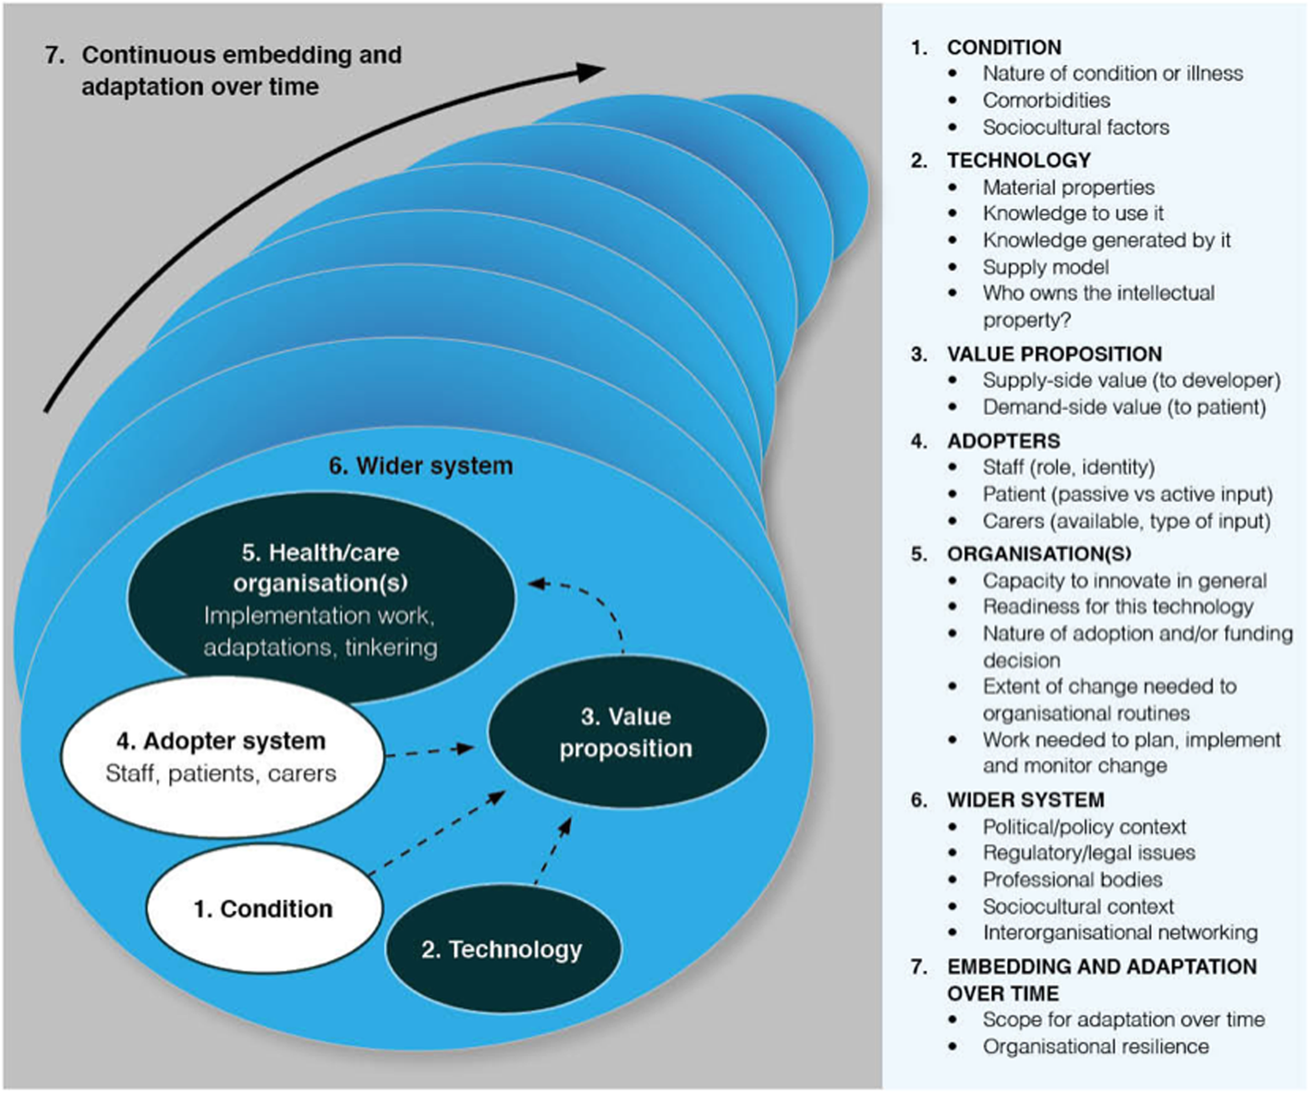

**Domain 1 is the illness or condition.** Complexity occurs when the condition is metabolically volatile (e.g. diabetes in pregnancy), inherently unstable (e.g. drug dependency), poorly described or understood (e.g. a newly discovered syndrome), associated with co-morbidities (most commonly in elders), or strongly influenced by socio-cultural factors (e.g. poverty, social exclusion) [[11](https://bmcmedicine.biomedcentral.com/articles/10.1186/s12916-019-1463-x#ref-CR11)].

**Domain 2 is the technology**. Complexity may relate to its material properties (e.g. functionality, dependability, speed), knowledge needed to use it, knowledge it brings into play (all technologies foreground some kinds of knowledge at the expense of others [[12](https://bmcmedicine.biomedcentral.com/articles/10.1186/s12916-019-1463-x#ref-CR12)]), supply model (e.g. is it substitutable?), and intellectual property (how easy is it to say who “owns” this?) [[13](https://bmcmedicine.biomedcentral.com/articles/10.1186/s12916-019-1463-x#ref-CR13)].

**Domain 3 is the value proposition**—both supply-side (value to the developer) and demand-side (value to the patient, healthcare system, and taxpayer or insurer). Complexity in this domain relates to difficulties in formulating a credible business plan (e.g. when efficacy or cost-effectiveness studies are unavailable or contested) [[14](https://bmcmedicine.biomedcentral.com/articles/10.1186/s12916-019-1463-x#ref-CR14), [15](https://bmcmedicine.biomedcentral.com/articles/10.1186/s12916-019-1463-x#ref-CR15)].

**Domain 4 is the adopter system:** the staff, patients, and carers who will be expected to use the technology (but who may refuse to use it or find they are unable to use it). Complexity may arise, for example, when the roles and practices assumed by the technology threaten professional traditions and codes of conduct [[16](https://bmcmedicine.biomedcentral.com/articles/10.1186/s12916-019-1463-x#ref-CR16)].

**Domain 5 is the organisation(s).** Complexity in this domain may relate to the organisation’s general capacity to innovate (such things as leadership, resources, and clinician-managerial relationships) [[17](https://bmcmedicine.biomedcentral.com/articles/10.1186/s12916-019-1463-x#ref-CR17)], its readiness for this particular technology (tension for change, balance of supporters and opponents) [[17](https://bmcmedicine.biomedcentral.com/articles/10.1186/s12916-019-1463-x#ref-CR17)], the nature of the adoption and funding decision (more complex if it depends on inter-organisational agreements and speculative cross-system savings), potential disruption to existing routines [[18](https://bmcmedicine.biomedcentral.com/articles/10.1186/s12916-019-1463-x#ref-CR18)], and extent of work needed to implement the changes (including gaining buy-in, delivering the change, and evaluating the change) [[7](https://bmcmedicine.biomedcentral.com/articles/10.1186/s12916-019-1463-x#ref-CR7)].

**Domain 6 is the wider system**, including the policy context, support from regulatory or professional bodies, and public perceptions [[5](https://bmcmedicine.biomedcentral.com/articles/10.1186/s12916-019-1463-x#ref-CR5)]. This domain also includes inter-organisational networking (for example, via quality improvement collaboratives), which can be a powerful way of spreading organisational-level innovations [[17](https://bmcmedicine.biomedcentral.com/articles/10.1186/s12916-019-1463-x#ref-CR17)].

**Domain 7 is embedding and adapting over time.** Complexity may arise from the technology’s “brittleness” (inability to adapt to changing context) or from the organisation’s lack of resilience (inability to withstand shocks and setbacks through learning and adaptation) [[19](https://bmcmedicine.biomedcentral.com/articles/10.1186/s12916-019-1463-x#ref-CR19)].